Cheetah

Software Architecture Document

Version 1.2

Revision History

|  |  |  |  |
| --- | --- | --- | --- |
| **Date** | **Version** | **Description** | **Author** |
| 23/11/2016 | 1.0 | Initial Version | Damian Pistorius, Lior Olszewski, Sara Olszewski |
| 04/04/2017 | 1.1 | Deployment View | Sara Olszewski |
| 16/05/2017 | 1.2 | MVC Pattern | Sara Olszewski |
|  |  |  |  |

Table of Contents

1. Introduction 4

1.1 Purpose 4

1.2 Scope 4

1.3 Definitions, Acronyms, and Abbreviations 4

1.4 References 4

1.5 Overview 4

2. Architectural Representation 4

3. Architectural Goals and Constraints 4

4. Use-Case View 4

5. Logical View 5

5.1 Architecturally Significant Design Packages 5

6. Process View 6

7. Deployment View 7

8. Implementation View 7

9. Database View (optional) 7

10. Size and Performance 7

11. Quality 7

Software Architecture Document

# Introduction

## Purpose

This document provides a comprehensive architectural overview of the system, using a number of different architectural views to depict different aspects of the system. It is intended to capture and convey the significant architectural decisions which have been made on the system.

## Scope

The scope of this SAD is to show the architecture of the Cheetah application. Affected are the class structure, the use cases and the data representation.

## Definitions, Acronyms, and Abbreviations

SAD Software Architecture Document

MVC Model View Controller

## References

MVC Framework for Ruby on Rails https://shijitht.files.wordpress.com/2010/09/mvc.png

## Overview

(n/a)

# Architectural Representation

This project will use the MVC architecture, which Ruby on Rails can realize.

# Architectural Goals and Constraints

The main goal of the MVC architecture is to separate the view from the logic. Therefore the view knows nothing on its own, but gets all information from the logical part. The Ruby on Rails framework automatically creates projects based on the MVC pattern.

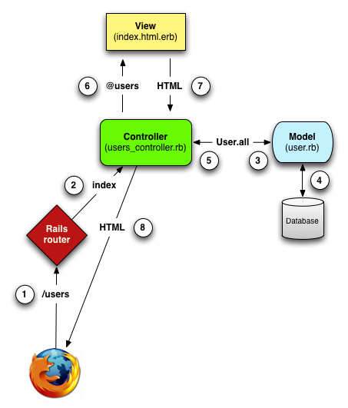

<https://shijitht.files.wordpress.com/2010/09/mvc.png>

# Use-Case View

(n/a)

# Logical View

## Architecturally Significant Design Packages

**Controller:**

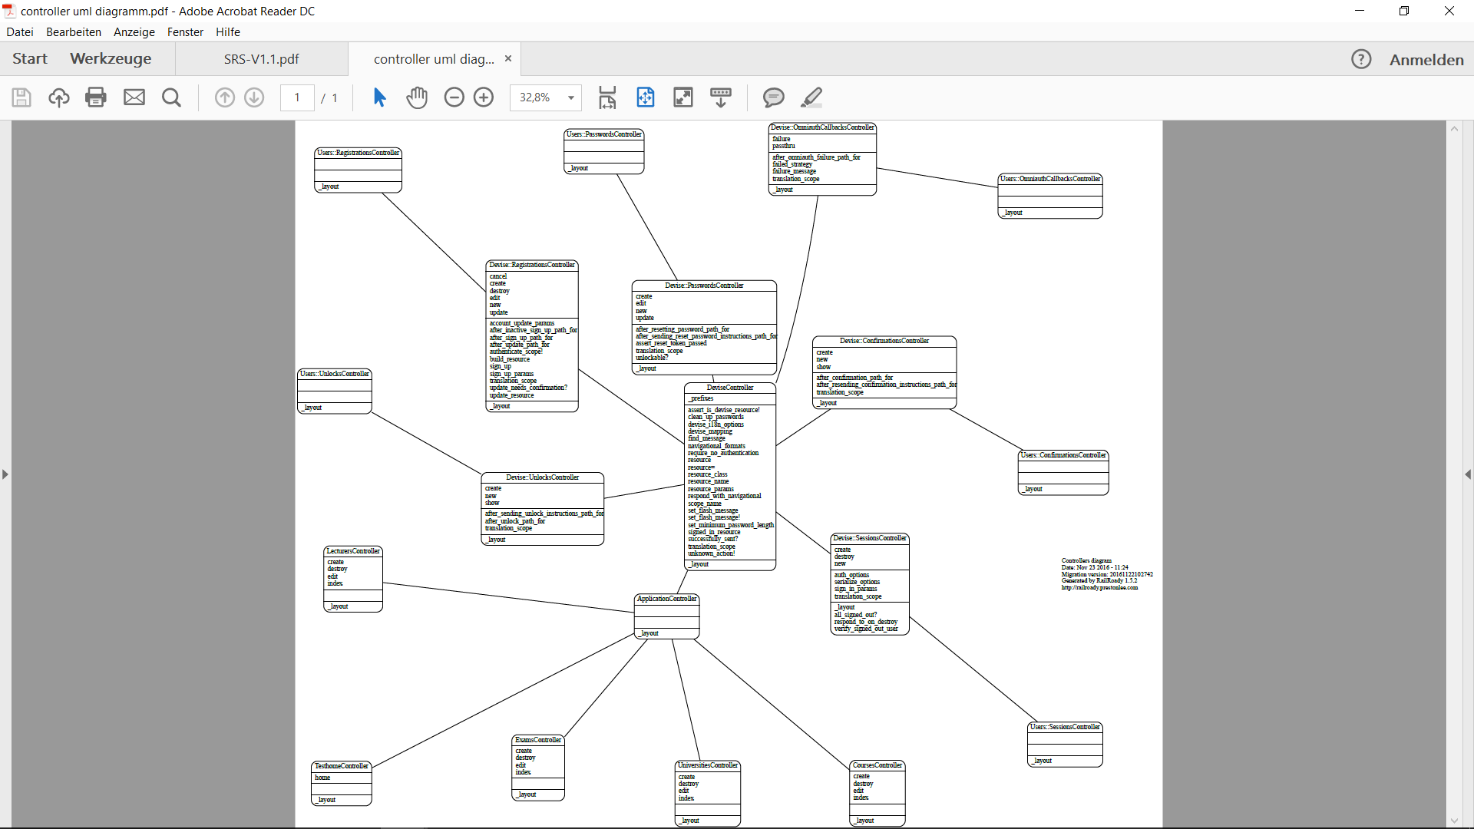

**Model:**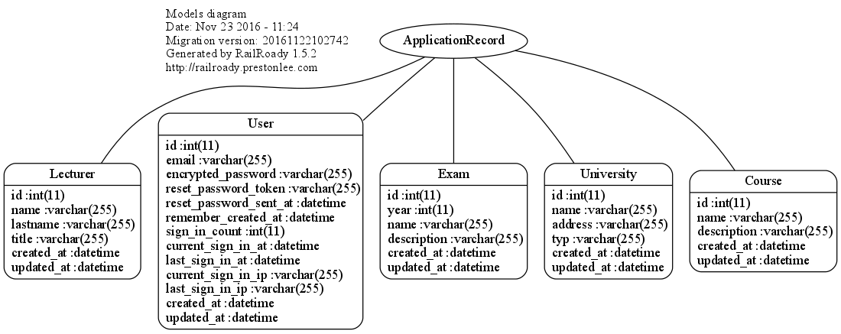

Models without pattern

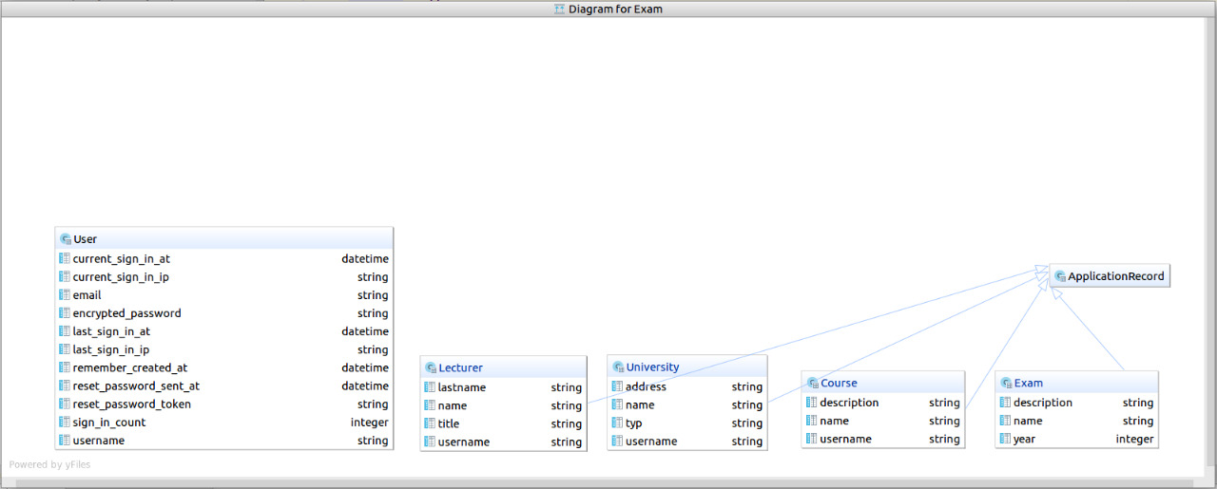

Models with dependencies pattern

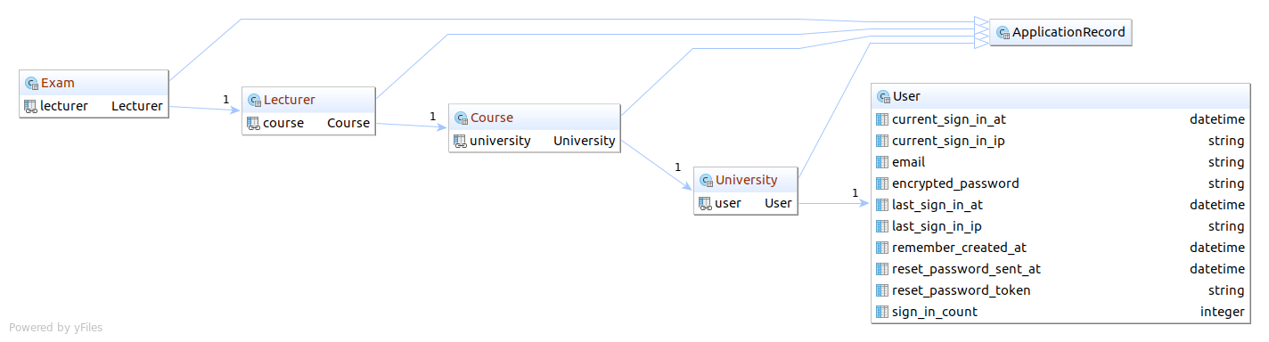

**View:**

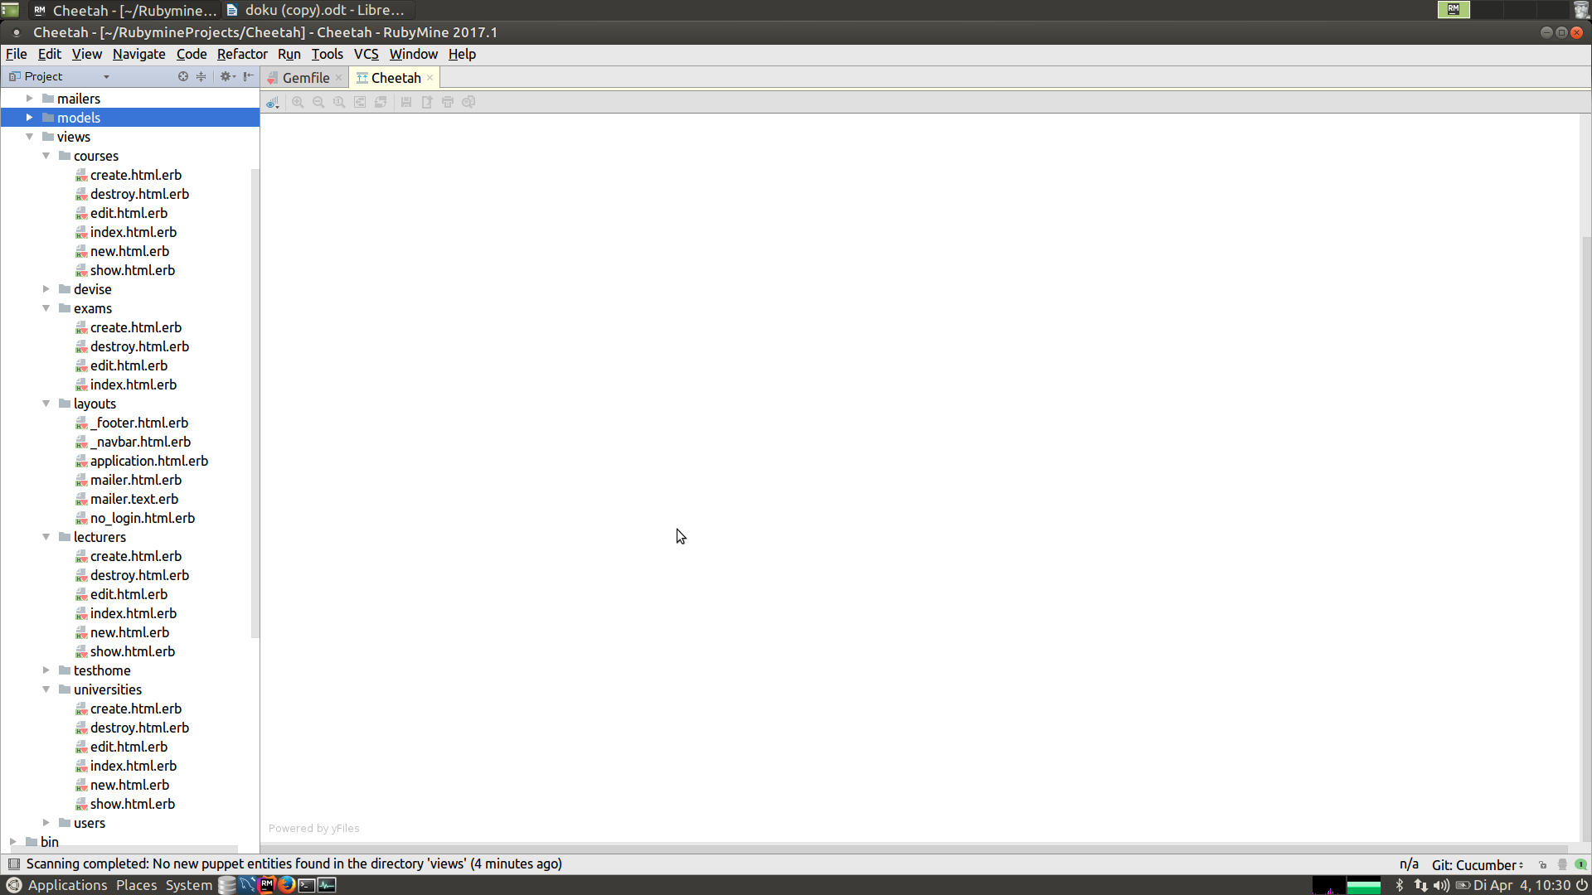

# Process View

(n/a)

# Deployment View

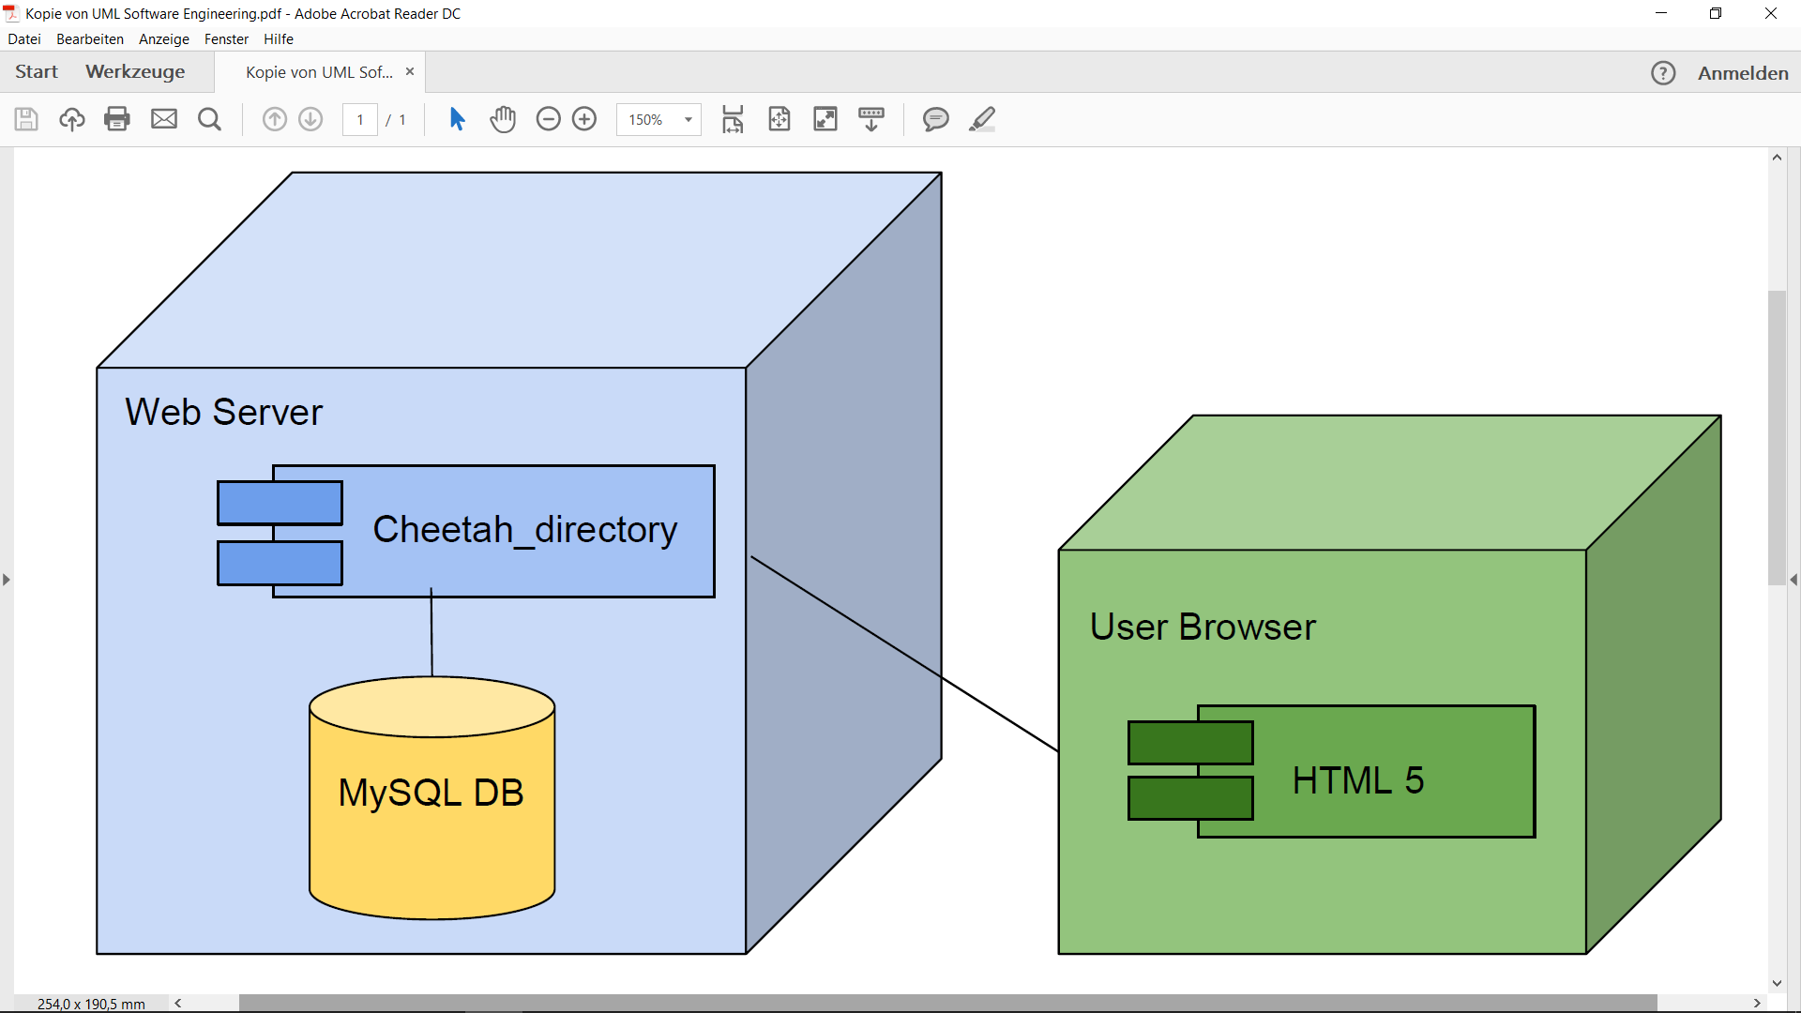

# Implementation View

(n/a)

# Database View (optional)

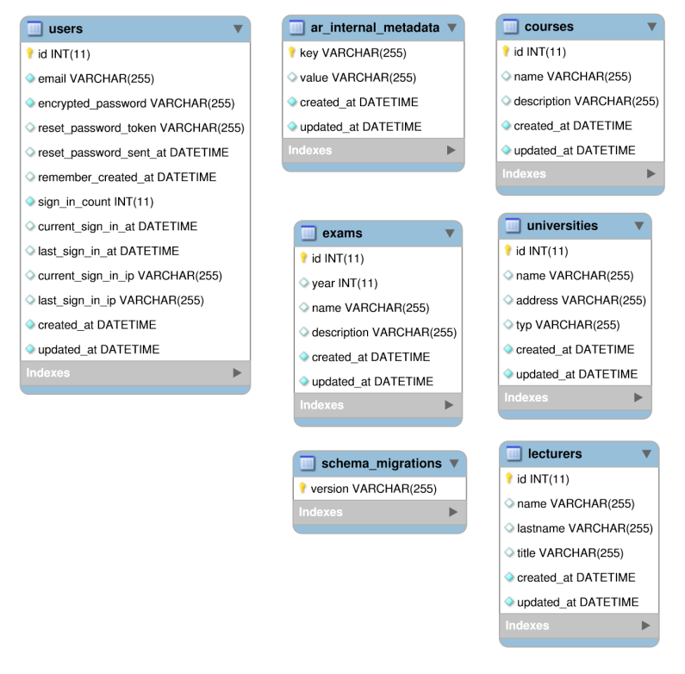

# Size and Performance

(n/a)

# Quality

(n/a)